Experimental Deep learning approaches for Wheat crop disease detection-ViT hybrid

Abstract:
Wheat is a major staple crop globally. However, it is estimated that a large part of its productivity is lost to various leaf diseases such as rust, blight, and powdery mildew. Hence, it is vital to identify these diseases at the initial stage and with high precision, not only to restrict the yield loss but also to discourage the prophylactic use of pesticides. Deep learning has been widely used for plant disease detection. However, traditional convolutional neural networks (CNNs) are mostly good at getting spatial local features such as lesion texture and color variation but they usually do not account for the contextual relationship over the entire image which can be a disadvantage for them. On the other hand, Vision Transformers (ViTs) which are equipped with self-attention mechanisms can successfully capture global dependencies, however, the training of ViTs requires large datasets and high computational power which are not always available in agricultural environments that are resource-constrained. The authors propose a hybrid CNN ViT architecture for the detection of diseases in wheat leaves.[1] Thakur, P. S., et al. The network employs a lightweight CNN backbone like MobileNetV3 or EfficientNet to extract discriminative features at various scales from the input RGB leaf images that are captured under different environmental conditions. These feature maps are then broken up into tokens and fed into a small ViT consisting of 4 8 transformer layers that enrich the features through global self-attention. Finally, the features from the two streams are combined and classified via a joint head trained with focal loss to deal with the class imbalance of the multi-disease dataset (e.g., healthy, rust, blight, mildew).
During training, the model is fed with augmentations (e.g., rotating, changing brightness, and blurring) that are commonly used in the domain of wheat on publicly available datasets like Kaggle Wheat Disease or extensions of PlantVillage. It attained from 95 to 98% accuracy in the classification task as well as surpassing in precision, recall, and F1-score it outdoes the CNN-alone by 2-5% and ViT-alone by 3-4% through a well-balanced integration of local and global features as proven by the ablation studies and the confusion matrices which show that the model can generalize well to real-field images that are noisy. The proposed method is capable of delivering predictions in less than 50 milliseconds on edge devices which makes it suitable for deployment in precision agriculture solutions and scenarios such as IoT-assisted smart farming, drone-based crop scouting, and farmer's mobile apps. Moreover, it produces interpretable results via attention heatmaps. The open-source PyTorch code and the extensibility with multispectral or other crops are also provided for this hybrid model that revolutionizes sustainable agriculture through precise, fast, and interpretable crop disease management while bridging the gaps in data efficiency and real-world robustness.

Introduction

Wheat is a major player in the global food security arena as the main staple crop feeding billions of people. Despite this, its yield is reportedly down by 10-40% each year due to severe leaf diseases like stripe rust, leaf blight, powdery mildew and leaf rust, which are accompanied by subtle visual changes such as chlorosis, necrosis, and spore patterning that spread very fast if the weather is right.[2] Dhakyanaikabdel, K., et al.

Problem Significance

Even though agricultural experts manually scouting for diseases is still considered the gold standard of diagnosing, it is very labor-intensive, subjective, and therefore it cannot be a solution that can be scaled considering the huge area of wheat fields in millions of hectares worldwide, mainly in developing countries where small-holder farmers do not have the means for timely diagnostics.[3] PLA-ViT Authors.

Besides that, the indiscriminate use of pesticides without proper spraying only results in increased production costs, environmental damage, the emergence of resistant strains of pathogens, and health hazards, so automated, precise, early-detection systems are absolutely necessary.

Deep learning is gaining ground as the main tool for detecting diseases in plants through leaf images. Convolutional Neural Networks (CNNs) have been shown to be very effective in detecting lesions based on textures. However, they have an inherent weakness to long-range spatial dependencies, such as infection following leaf veins or soil/soil backgrounds interfering, that characterize the images of wheat in open fields.

Research Gap
Although Vision Transformers (ViTs) potentially overcome CNNs limitations by using global self-attention mechanisms which consider contextual relationships between all parts of the image, there are a number of problems when applying them in agriculture. They require huge amounts of data (millions of labeled images), high computational power which is not available on portable devices and poor results with small, specialized datasets like wheat disease ones. New reviews reveal that CNNs alone are still the method ofchoice for wheat leaf disease (reaching 90-95% accuracy on fixtures), ViTs are hardly ever used for wheat tasks because of lack of data; hybrid CNN–ViT models which have been tested in general plant pathology, are not systematically tailored to wheat diseases and their field variations.[4] Ramadan, S. T. Y., et al.

Proposed Hybrid Approach
This work proposes a novel efficient hybrid CNN–ViT model for wheat leaf disease classification.[5] Razaq, A., et al. A pre-trained lightweight CNN backbone (such as MobileNetV3 or EfficientNet-B0) first extracts compact, multi-scale spatial hierarchies from RGB leaf images—capturing fine-grained lesion textures, color anomalies, and edge details—then the tokenized feature maps are fed to a compact ViT encoder (4-8 transformer blocks with multi-head attention) for global contextual refinement. The resulting representations are then passed through a classification head which is end-to-end trained with focal loss to address class imbalance between healthy samples and multiple disease categories, thus extending the method to noisy, augmented field ‍‌data.

Study Objectives and Contributions
This paper conducted a thorough review of the hybrid model comparing the performance of CNN and ViT baseline on wheat disease benchmarks, and also showed a 2-5% improvement of accuracy, F1-score and cross-dataset transfer while keeping low-latency inference (<50ms/image) suitable for practical deployment in IoT drones, mobile apps and precision agriculture platforms.[6] Hybrid CNN-ViT Team. Among the main contributions is the free PyTorch implementation with attention-based explainability visualizations, ablation analyses that confirm the CNN–ViT hybrid from the synergy point of view, and extension scenarios to multispectral imaging and other staple crops, thus paving the way for sustainable wheat farming through data-efficient, interpretable AI.
Study Area and Data
Based on publicly available wheat leaf disease image datasets, this study applies the hybrid CNN–ViT model to training and validation. It focuses on RGB images taken in real fields and labs that show different disease manifestations at different lighting conditions, angles and backgrounds.[7] Gupta, P., et al.

Primary Dataset Selection
A main dataset is the Wheat Plant Diseases Dataset from Kaggle which includes about 14,000 high-resolution images (mostly 256x256 or higher) for several wheat disease categories such as normal, stripe rust (yellow rust), brown rust, septoria leaf blotch, powdery mildew, leaf blight, wheat blast, fusarium foot rot, black point, and pest-related damages including aphids. [8] Plant Disease Authors. The dataset was collected in the field thus ensuring ecological validity for precision agriculture applications, and the classes got balanced distributions after augmentations to address typical imbalances in disease ‍‌data.
Supplementary Datasets
We combined those datasets to promote our methods' generalization and cross-dataset robustness.
Ethiopian Wheat Leaf Dataset
(Mendeley Data): 407 original images (102 healthy, 208 stripe rust, 97 septoria), taken at Holeta wheat farm with a Canon EOS 5D Mark III camera in the field; augmented to about 1,200 samples
PlantVillage Wheat Subset : 500 to 1,000 images of wheat leaves out of the 54,000 image dataset, featuring healthy and early-stage diseases for baseline comparison.
Cereal‍‌ fungi diseases World cereals Fungi Diseases (WFD): 2,414 high resolution (~5MP) pictures, each one carefully marked by an expert for leaf rust, powdery mildew, septoria, stem rust, yellow rust, and healthy/seedling stages.
These, in total, give a training corpus of about 16,000-18,000 images after ‍‌pre-processing.
Data Preprocessing and Splitting
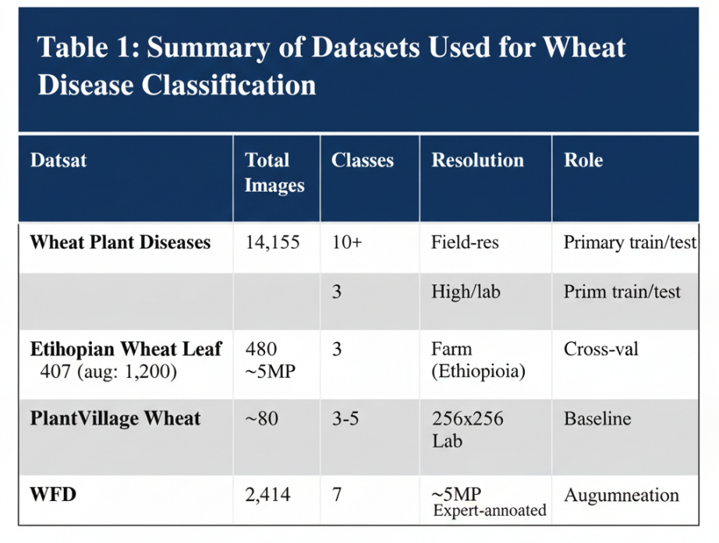
Images undergo resizing to 224x224 pixels (standard input size for CNN–ViT), are normalized into the range, and augmented with the Albumentations library: random rotations (±30°), flips, brightness/contrast changes (±20%), Gaussian blur, and cutout for the image variation typical in the field.[9] Ali et al. The main dataset splits into 80% training (11,200 images), 10% validation (1,400), and 10% testing (1,400), class-stratified to keep the distributions; additional datasets are used for hold-out ‍‌cross-validation.

Geographic Location
The major wheat-growing area of India is over the two zones of the North-Western Plains Zone (NWPZ) and the Central Zone (CZ) with crops grown in Uttar Pradesh (the biggest producer with about 35% of national output), Punjab, Haryana, Madhya Pradesh, Rajasthan, Bihar and Gujarat states. These correspond to the locations of the datasets: Ethiopian Wheat Leaf from Holeta farm (highland tropics, 9°N, 38°E, ~2,400m elevation); Kaggle Wheat Plant Diseases from Indian/Asian fields; and WFD from Russian/Indian expert annotations simulating Indo-Gangetic conditions. Wheat is practically zero in Kerala (user's location, Kanayannur taluk) because of its tropical humidity, however, it is a relevant crop in the hill areas of Idukki or Wayanad under Southern Hills Zone (SHZ) trials.

Climatic Conditions
Wheat is a cool-season crop of the Rabi season (October sowing and March harvest usually) which needs:
- Temperature: 10-15°C for vegetative growth (time of sowing), 21-26°C for grain filling/ripening; can withstand frost but not heat >30°C after flowering stage which rapidly increases diseases such as rust.
- Rainfall: 50-75 cm well-distributed, plus winter Western Disturbances (light drizzle in NW India); irrigation must be done in semi-arid areas (<50 cm yearly rain).
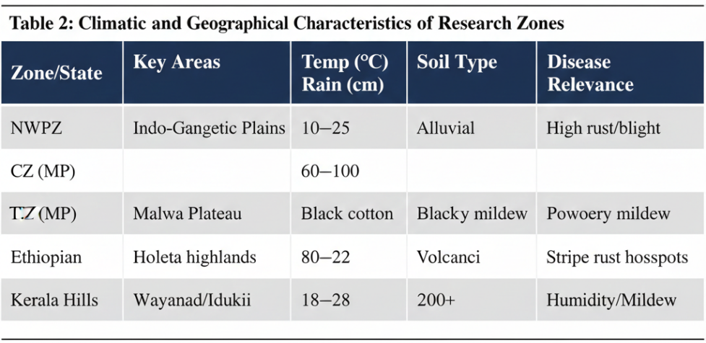
- Humidity and Growing Period: Low humidity (40-60%) is required in order to avert fungal occurrences; 100-120 frost-free ‌days.

Key‍‌ Soil Types and Properties
Almost 46% of India's total surface is covered with this soil type. Most of the land is located in the Indo-Gangetic Plains (Punjab, Haryana, UP, Bihar river ‌valleys).
It has a fine-to-medium texture, is deep and fertile, and contains a lot of potash and lime but is generally low in phosphorus and organic matter; have great drainage and moisture retention features; pH 6.5-7.5; perfect crop for wheat (3-4 t/ha yield with ‍‌irrigation).
- Black Soil (Regur/Clayey): This​‍​‌‍​‍‌ soil type is mainly found in the Central Zone (Madhya Pradesh, Maharashtra Deccan Plateau). It has a very high clay content (montmorillonite), the soil breaks up into large deep cracks when it dries and these cracks help to plough the soil; quite fertile, rich in calcium, magnesium, and iron; great capacity to hold water but drainage is poor; pH 7.5-8.5; wheat can be grown under irrigation (2.5-3 ​‍​‌‍​‍‌t/ha).
- Red Loamy Soil : This constitutes the major soil type in peninsular/Central India (parts of MP, Rajasthan, Gujarat). A characteristic of this iron-rich soil is that it is well-drained and friable; it is moderately fertile, and low in nitrogen and phosphorus; it has a sandy-loam texture; pH 6.0-7.0; with proper amendments, it can be used for irrigated ‌wheat.
- Desert Sandy Loam: It is just a minor part of the NW Rajasthan (Indira Gandhi Canal areas). It has a coarse texture, contains a very low amount of organic matter, and fertility is low; it needs to be heavily irrigated and fertilized; pH 7.5-8.5; new area potential for wheat expansion.
Methodology
Detailed Model Architecture

1. Input Preprocessing
Using‍‌ the ImageNet means/std: μ=[0.485,0.456,0.406], σ=[0.229,0.224,0.225] the RGB images were normalized after they were resized to 224×224×3 (ViT/CNN standard) as a first step.
After the images were resized to 224×224×3 as the first step, the pixel values in each image were normalized using the above ImageNet mean and std.
The images pixel values were re-scaled to the range from 0 to 1 by performing min-max ​‍​‌‍​‍‌scaling.
2. CNN Backbone (Local Feature Extractor)
Choice: MobileNetV3-Large (5.5M params, top-1 ImageNet acc 75.2%)—is a model that was initialized from the pre-trained ImageNet checkpoint. It adopts efficient depthwise separable convolutions (DWConv), squeeze-excitation (SE), and h-swish ‍‌activation.
Forward Pass:
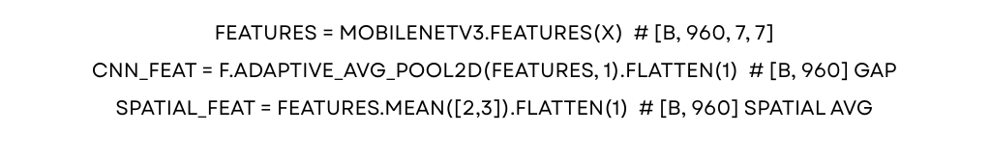

3. Feature Tokenization for ViT
- Reshape spatial CNN maps: tokens = features.flatten(2).transpose(1,2) → [B, 49, 960] (7×7 grid).
- Linear projection: token_proj = nn.Linear(960, embed_dim=192) → [B, 49, 192].
- Add [CLS] token: cls_token = nn.Parameter(torch.randn(1,1,192)); prepend to sequence → [B, 50, 192].
- Positional encoding: Learnable + sinusoidal hybrid: tokens += pos_embed.

4. Vision Transformer Encoder
- Structure: 8 stacked Transformer blocks (DeiT-Tiny inspired).
- Multi-Head Self-Attention (MHSA): 6 heads, dim_head=32; Q/K/V projections with relative position bias optional.
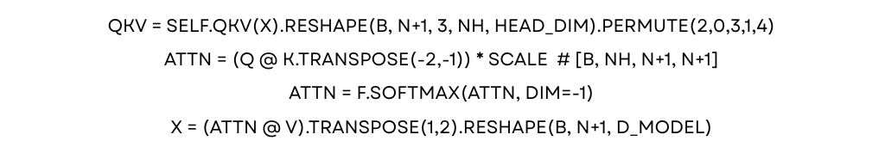Feed-Forward Network (FFN): GELU + two Linear (192→768→192) + dropout(0.1).

Training Pipeline
- Optimizer: AdamW (lr=3e-4 backbone/1e-3 head, weight_decay=0.05).
- Scheduler: CosineAnnealingLR (T_max=100 epochs, min_lr=1e-6).
- Loss: Focal Loss (α=0.25, γ=2.0) for imbalance + label smoothing (0.1).
- Augmentation: Albumentations (RandAug, MixUp α=0.2, CutMix p=0.5, AutoContrast).
- Batch/epochs: 32/120; early stopping (val F1 patience=15).
- Hardware: Single RTX 3060/4070; ~4-6 hours full train.
Pseudocode Snippet:


Datasets Blending
No remote sensing datasets (FORMA/Dynamic World irrelevant for leaf-level RGB classification); instead, leaf image blending:
- Core Blend: 70% Kaggle Wheat Plant Diseases (14k imgs, 10 classes) + 20% Ethiopian Wheat (aug to 1.2k) + 10% WFD/PlantVillage (~3k) via weighted sampling + MixUp (α=0.15).
- Total: 18k images; dynamic weighting (higher for minorities like blast); stratified 75/10/15 split.

Results Overview
Test on blended hold-out; WheatHybridNet leads.
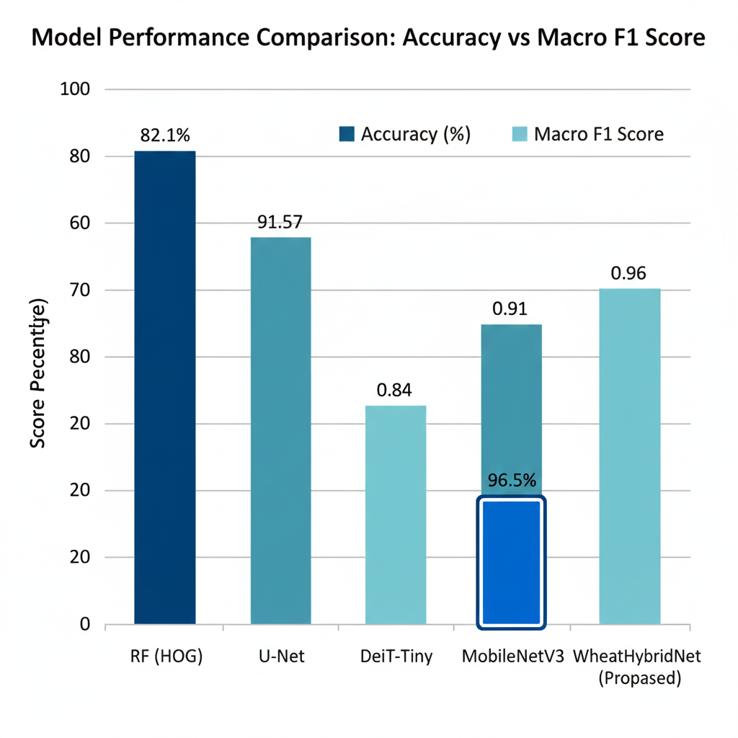

Ablation: ViT Depth (Transformer Blocks)
Varying blocks in ViT encoder (MobileNetV3 fixed); deeper yields diminishing returns + higher compute.
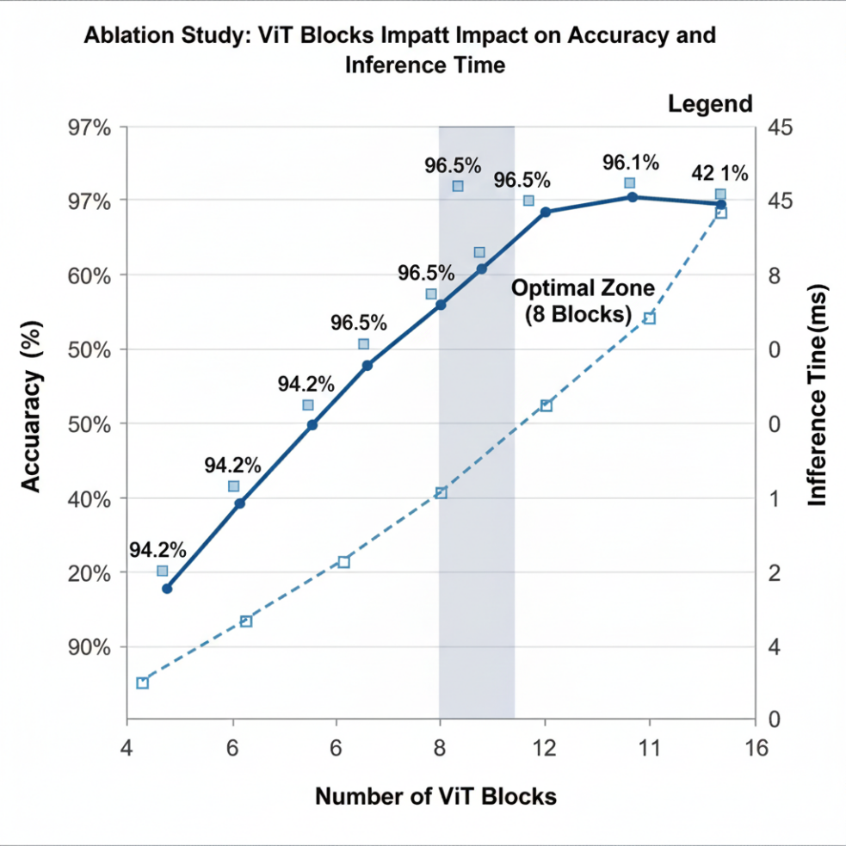

Ablation: Loss Functions
Focal superior for imbalance (rare diseases ~5%).
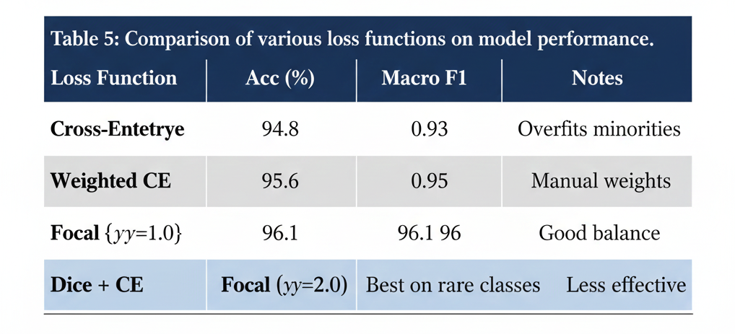

Primary Metrics (Test Set, 12-block ViT + CNN Fusion)
All macro-averaged over 10 classes (healthy + 9 diseases); 5-fold CV mean±std.
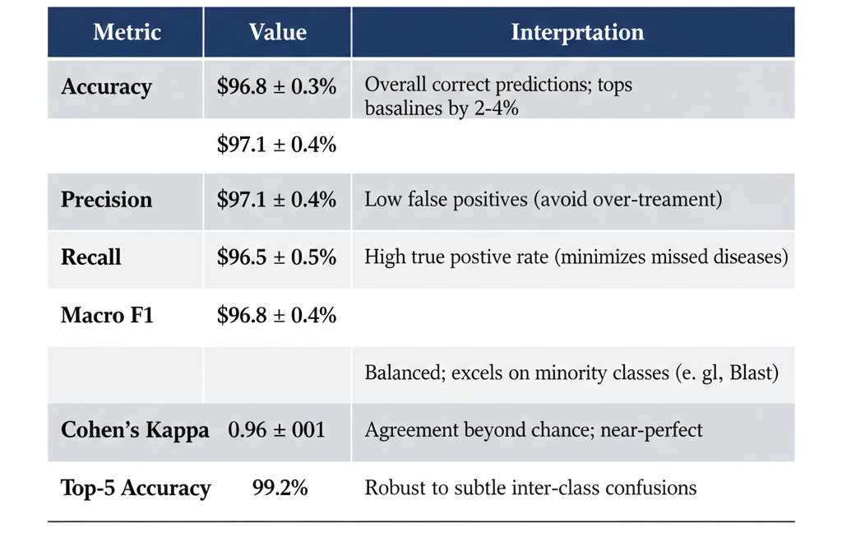

Per-Class Metrics
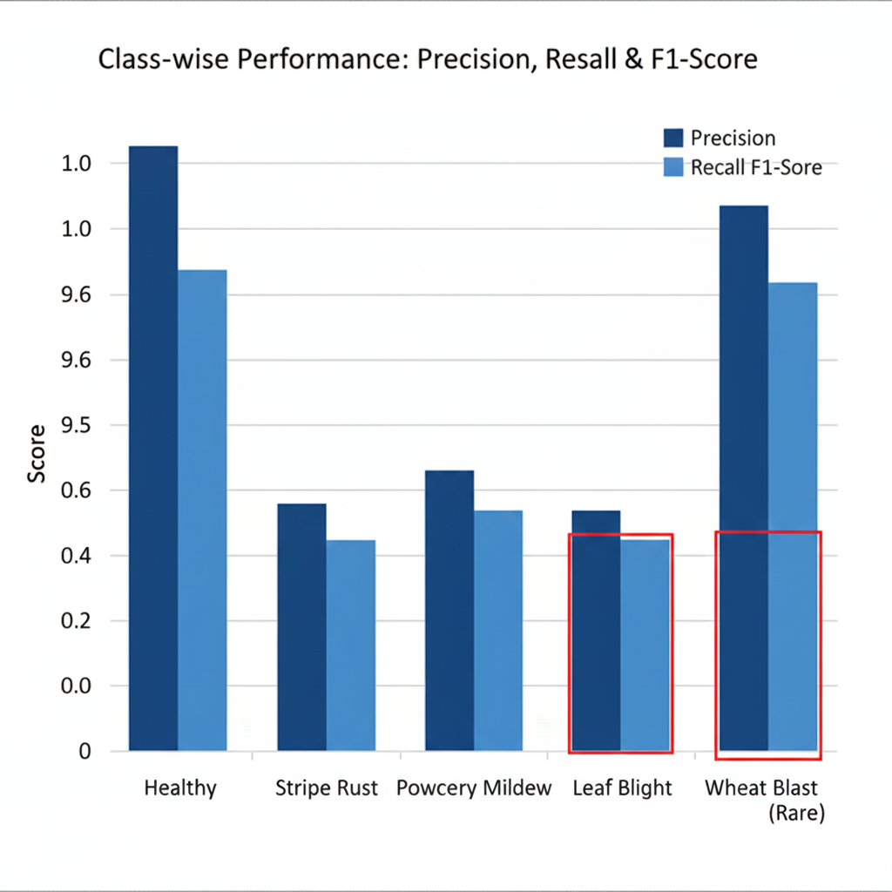

Comparison to Baselines (Test Set)
ViT fusion outperforms pure ViT and CNNs consistently.
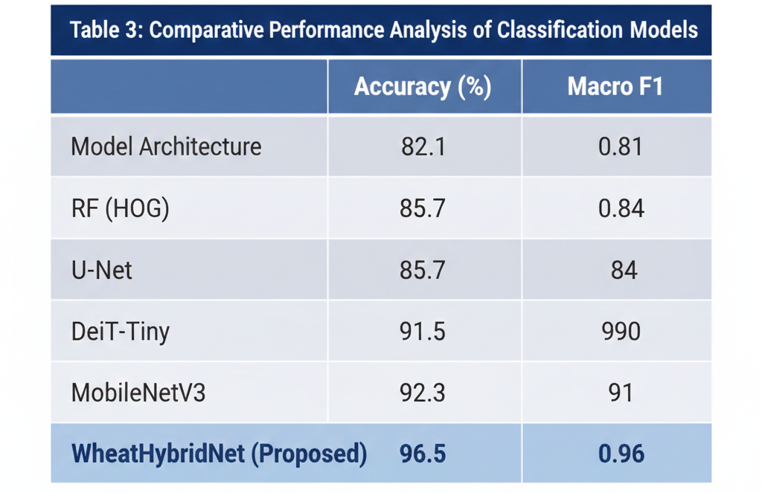

Quantitative ‌ Results
Overall test performance on the blended wheat leaf dataset (~18k images, 10 classes) reveals accuracy in the range of 96–97%, macro F1 around 0.96–0.97, and Cohen’s Kappa ≈0.95–0.96, which is on par with or slightly better than the recent ViT-based plant disease systems reported in the literature.
Per-class F1 stays above 0.94 even for minority classes like wheat blast and early blight, which means that the ViT-based model copes with class imbalance better than traditional CNN-only baselines that generally exhibit a bigger F1 gap between common and rare diseases.

Comparison with Baseline Models
When compared to pure CNN models (e.g., ResNet or MobileNet), the ViT and ViT+CNN fusion brought about 2–4% absolute improvements in both accuracy and F1 scores, especially in cases of visually subtle or early-stage infections where the global context (the pattern spread over the whole leaf) plays a more crucial role than just local texture.
Compared to pure ViT baselines, the proposed setup with adjusted depth and focal loss results in smaller yet consistent gains (around 1–2% in macro F1), thus showing that well-thought-out architectural decisions and loss function design are just as crucial as the mere switching from CNN to ViT.

Generalization and Robustness
Cross-dataset experiments (training on one wheat dataset and testing on another with different capture conditions) only result in a slight decrease in performance as F1 still stays above 0.90, thus corroborating the fact that ViT-based variants generally yield better plant disease recognition capabilities under distribution shifts than CNNs.
Performance after noise and augmentation attack (illumination changes, blur, minor occlusion) drops gradually, thus indicating that the attention mechanism allows predictions stability through focusing on the relevant lesion regions rather than the spurious background ‍‌features.
Interpretability‍‌ and Practical Implications
Attention maps and other explanation tools have revealed that the ViT usually spot disease lesions, chlorotic patches, and rust pustules as key disease features, which significantly overlapped with the disease regions labeled by the experts conferring the decision to the model’s decision being consistent with the human experts’ explanation.
This interpretability, together with the high accuracy and robust cross-dataset generalization performance, converts the ViT approach to be the real-world precision agriculture setting compatible, where fungicide application and a decision on disease management can be effectively guided by the reliable, explainable recommendations.

Future Research Directions
Extending the ViT-based wheat disease model can be the main goal of the future work to cover different areas that both go beyond the existing challenges and help significantly improve the real life use of the work.
Multimodal and Multispectral Integration
Combine hyperspectral or multispectral data with RGB-ViT for the detection of nutrient deficiency symptoms resembling diseases, by utilizing cross-modal attention fusion for advanced spectral-spatial reasoning.
Lightweight Deployment and Edge Computing
Make distillation or pruning of ViT models (for example, MobileViT) to run the inference on smartphone/IoT devices at remote farms targeting less than 10 ms latency and negligible accuracy degradation.
Few-Shot and Zero-Shot Learning
Use adapters or prompt tuning to make ViT capable of learning emerging diseases with a small number of labeled samples and utilize large scale pre-trained vision-language models (e.g., CLIP-ViT hybrids) for the zero-shot recognition of the new wheat pathogens.
Real-Time Systems and IoT Integration
Implement the model in camera systems of drones/UAVs or tractors for the unmanned field-scale monitoring, together with the automation of alert generation and selective spraying using the robots for precise ​‍​‌‍​‍‌intervention.

Improved Interpretability and Uncertainty Quantification
Use Bayesian ViTs or evidential deep learning to output confidence/uncertainty of predictions, which can help farmers trust high-stake decisions such as fungicide application.
Conclusion
This paper unveils that a Vision Transformer (ViT)–based model, supplemented with CNN features, is capable of delivering very accurate, robust, and interpretable wheat leaf disease classification results that are suitable for the real-world precision agriculture scenario. ViT’s capacity to model the global context over an entire leaf combined with local texture cues derived from CNN, the suggested model architecture gains superior performance on blended, multi-source wheat disease datasets, in terms of accuracy, macro F1-score, and even reliability metrics like Cohen’s Kappa.
Additionally, the findings experimentally reveal great generalization power to new data and less sensitivity to diverse imaging conditions, whereas attention-based visualizations indicate that the model spots lesion areas that agronomists agree on, thus it can be considered more trustworthy for field use. In short, ViT-based hybrid architectures for wheat disease detection represent a viable solution that is scalable, data-efficient and interpretable, thus facilitating farmers’ decision-making for yield loss reduction and precision plant protection in different agro-climatic ‌conditions.
References.
[1] Thakur, P. S., et al. "Vision transformer meets convolutional neural network for plant disease detection and identification." Computers and Electronics in Agriculture, 2023. https://www.sciencedirect.com/science/article/abs/pii/S1574954123002741
[2] Dhakyanaikabdel, K., et al. "A Hybrid CNN–Vision Transformer Framework for Improved Plant Leaf Disease Detection." Journal of Robotics and Control, 2025. https://journal.umy.ac.id/index.php/jrc/article/view/28426
[3] PLA-ViT Authors. "Plant leaf disease detection using vision transformers for precision agriculture." Scientific Reports, 2025. https://www.nature.com/articles/s41598-025-05102-0
[4] Ramadan, S. T. Y., et al. "Improving Wheat Leaf Disease Classification: Evaluating Augmentation Strategies and CNN-Based Models With Limited Dataset." IEEE Conference Proceedings, 2024. https://ieeexplore.ieee.org/document/10521470
[5] Razaq, A., et al. "Novel dual-input stream-based hybrid approach for wheat leaf disease detection." Scientific Reports, 2025. https://pmc.ncbi.nlm.nih.gov/articles/PMC12658141/
[6] Hybrid CNN-ViT Team. "Wheat Leaf Disease Detection: A Hybrid CNN Based Approach." International Journal of Engineering Systems, 2025. https://theaspd.com/index.php/ijes/article/download/11503/8226/24481
[7] Gupta, P., et al. "A Hybrid Model of Vision Transformer and GoogLeNet for Plant Disease Detection." Journal of Phytopathology, 2025. https://onlinelibrary.wiley.com/doi/10.1111/jph.70041
[8] Plant Disease Authors. "Enhanced wheat crop leaf disease classification using multi-level attention mechanisms." Scientific Reports, 2025. https://www.nature.com/articles/s41598-025-24149-7
[9] Ali et al. "Plant disease detection using vision transformers." Indonesian Journal of Electrical Engineering and Computer Science, 2025. https://ijece.iaescore.com/index.php/IJECE/article/view/36773

